# Tasks

Here are 6 tasks to try with the Thymio Scratch interface.

For reference, here is a list of all of the broadcasts that the interface can use: **forward, backward, left, right, null, direct, command and arc**. If a command is **not available from the dropdown list then click on new and add it again.**

**Press “C” or broadcast command** to enable the interface to use the commands for the next few tasks.

Key events have already been included. The arrow keys broadcast in their directions and the space bar broadcasts null. Try using the arrow keys to make the Thymio move. The scroll wheel will act as either up or down in Scratch and commands will queue so be careful not to accidentally queue lots of actions.

## 1 basic movement

Inside sprite one, use the broadcast tile to make the robot do the following

* Move forward
* Turn right
* Move forward
* Move backwards
* Turn left
* Move backwards

You will need to use the tile as pictured below

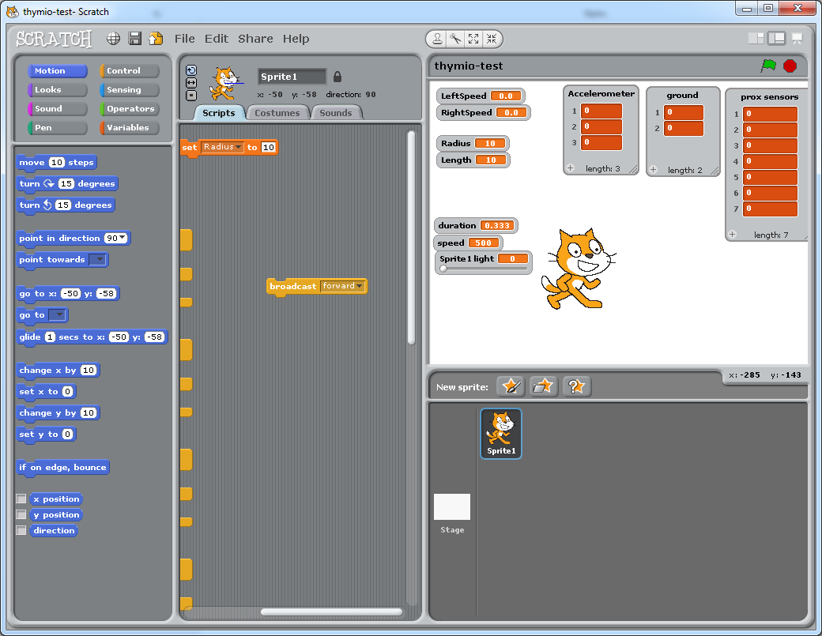

Note how all of commands are sent almost straight away and that they the stack up, being performed one after the other.

## 2 Movement conditions

Repeat the same task as before, this time however, us the set variable to change the duration and the speed. Duration must be positive and duration is in seconds and the speed must be between 500 and -500. After entering the value in the box, make sure to click on the box, a white outline should appear and will indicate it has been run.

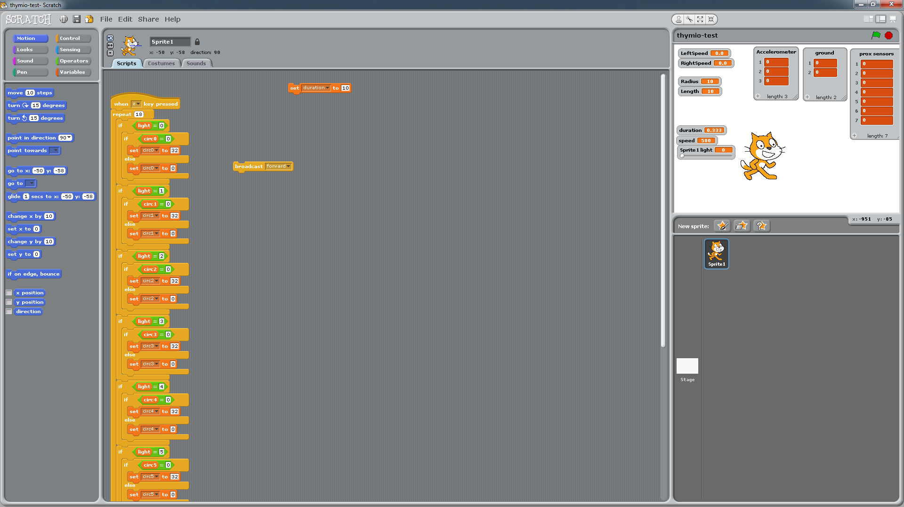

Now set the duration to 0 and use the wait function to time broadcasts and the null broadcast to stop the Thymio.

Try to make the Thymio do the following:

* Move forward at speed 500 for 1 seconds
* Rotate left as speed 200 for 0.5 seconds
* Stop for 1 second
* Move backwards at speed -200 for 0.5 seconds
* Stop

Notice how moving backwards at a negative speed causes the Thymio to move forwards.

## 3 Arc Movement

The Thymio can also be programed to move in an arc. The arc command works differently to the others as it doesn’t use the duration. Instead it uses a **radius and length** variable, both in centimetres to define the size of the radius of the arc and to define the distance that should be travelled. **Set the radius to 10 and the length to 10** as well and then broadcast arc. If arc is not in the dropdown list on the broadcast tile then you will have to add it as a new message.

Notice how the wheels move at different speeds in order to make the Thymio move in an arc. The radius is from the centre of the pen hole and the distance to the wheels is 5cm, try setting the radius to 4 and -3.

The arc cannot have a radius of 0, if it did then the centre would never travel and so it would try to move forever.

## 4 Direct wheel control

You may have noticed the direct and command broadcast. So far we have been using the commands but you can control the wheels individually. Instead of broadcasting, set the **LeftSpeed and RightSpeed variable to control the wheels**. To enable this mode you will need to **press “D” or send the command “direct”.**

Using these variables make the Thymio do the following.

* Left speed set to 0, right speed set to 400 for 0.7 seconds
* Left speed set to 500, right speed set to -500 for 1 second
* Left speed set to 100, right speed set to 100 for 2 seconds
* Left speed set to -500, right speed set to 0 for 1 second
* Stop

This mode has no built in stop command so you will have to stop it manually by setting the speeds to 0.

## 5 Sensors

When you started the interface you were asked what sensors you wanted to use, that was because they are broadcast to Scratch every 10th of a second. In the top right window in Scratch there should be 3 lists. The “prox sensor” list stores all the values from the infra-red sensors along the front and back of the Thymio. The ground list stores the values of the 2 sensor one the underside of the Thymio. These don’t record the distance however but instead use ambient light and reflected light to get a more reliable reading. The larger the value the more likely it is that it has gone off the end. The final list is the accelerometer list. This stores the values of the 3 axis for the accelerometer.

Program the Thymio to move forward when there is an object close behind it.

Program the Thymio to turn when the sensors to the side detect an object.

If you are finding this hard, remember that Scratch is very good at parallel processes. One loop could look for objects and then broadcast a message that would start another process. You can broadcast any message and the “when I receive …” tile to react to that broadcast

## 6 Avoid objects

Build on the previous task to make the robot move around an area while avoiding objects and determining the best direction to move in when it does encounter an obstacle.